**TO SUPPLY LEFTOVER FOOD TO POOR**

**COLLEGE NAME:**

GOVERNMENT ARTS COLLEGE,UDUMALPET

**COLLEGE CODE**:

arbu09

**TEAM ID:**

NM2025TMID25049

**TEAM MEMBER:**

**TEAM LEADER NAME: S.KANJANA DEVI**

**EMAIL:** [kanjanadeviselvaraj@gmail.com](mailto:kanjanadeviselvaraj@gmail.com)

TEAM MEMBER 1: Y.AISWARYA

EMAIL: [yesukanth39@gmail.com](mailto:yesukanth39@gmail.com)

TEAM MEMBER 2: P.SHANTHINI

EMAIL: [mm4763017@gmail.com](mailto:mm4763017@gmail.com)

TEAM MEMBER 3: S.SUBALAKSHMI

EMAIL: [subalakshmisakthivel507@gmail.com](mailto:subalakshmisakthivel507@gmail.com)

**INTRODUCTION**

**PROJECT OVERVIEW**

“Leftover food(Hotels, Functions, Canteens) is managed through a Salesforce application and supplied to poor people via NGOs/Volunteers.”

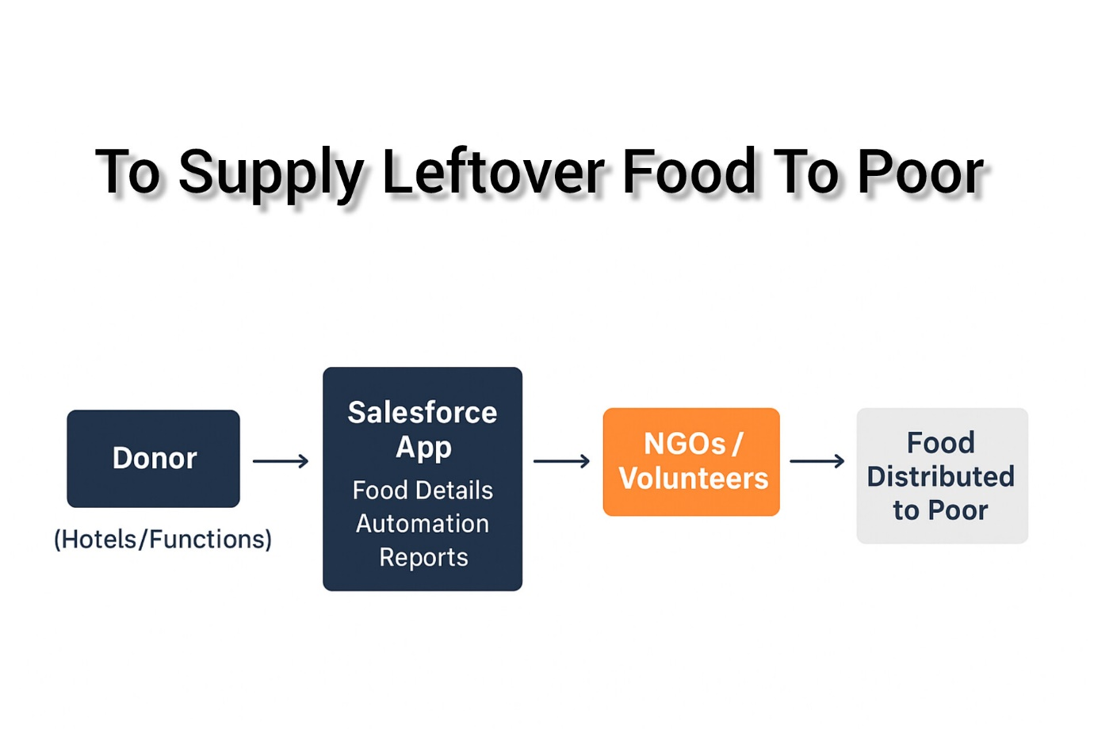

**PURPOSE**

**The main purpose of this project is:**

* To reduce food wastage from hotels, restaurants, canteens, and functions.
* To collect and manage leftover food using a Salesforce application.
* To connect donors with NGOs/volunteers for efficient distribution.
* To ensure timely delivery of food to poor and needy people.
* To track donations, volunteers, and distribution through reports and dashboards.

**DEVELOPMENT PHASE**

* **Creating Developer Account:**

By using this URL - <https://developer.salesforce.com/signup>

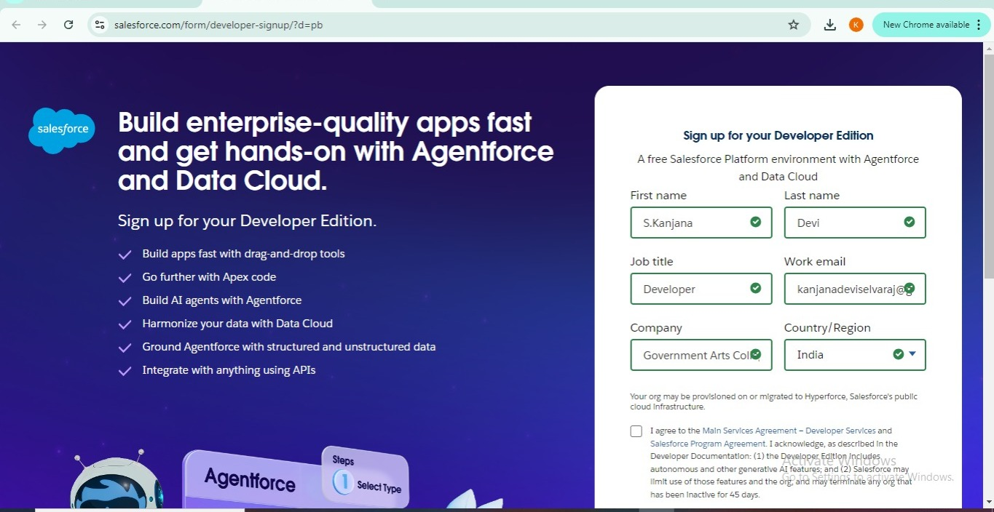

* **Created Objects:**

Venue , Drop-Off Point , Task , Volunteer , Execution Details.

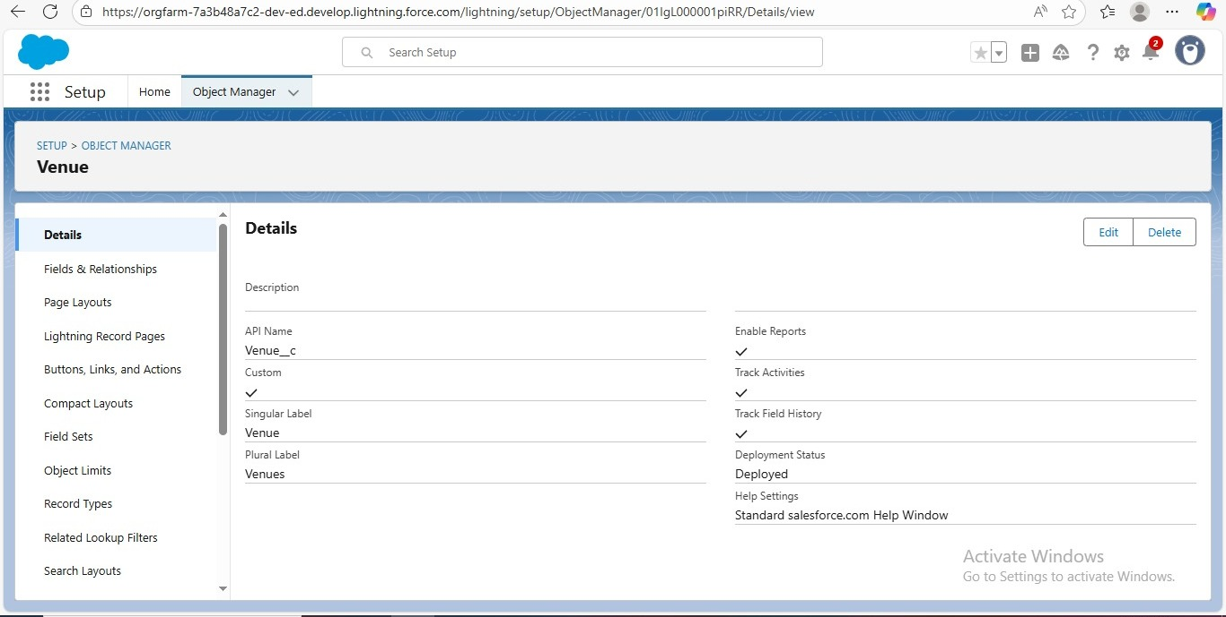

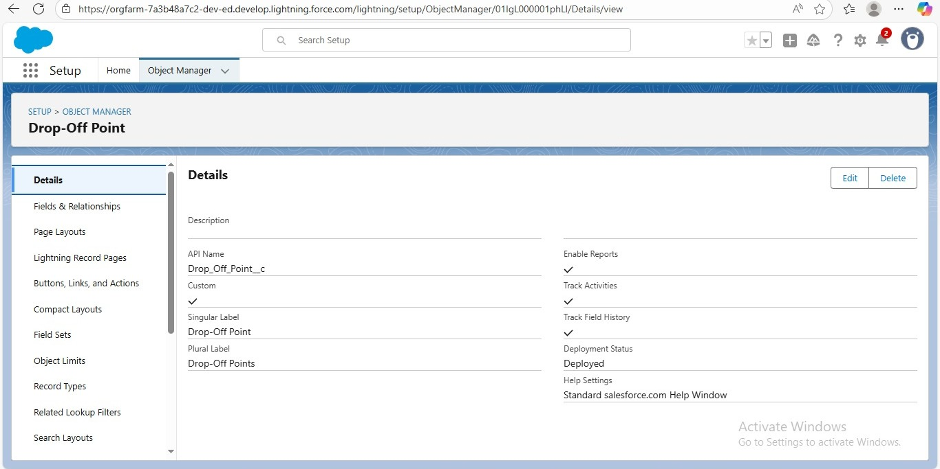

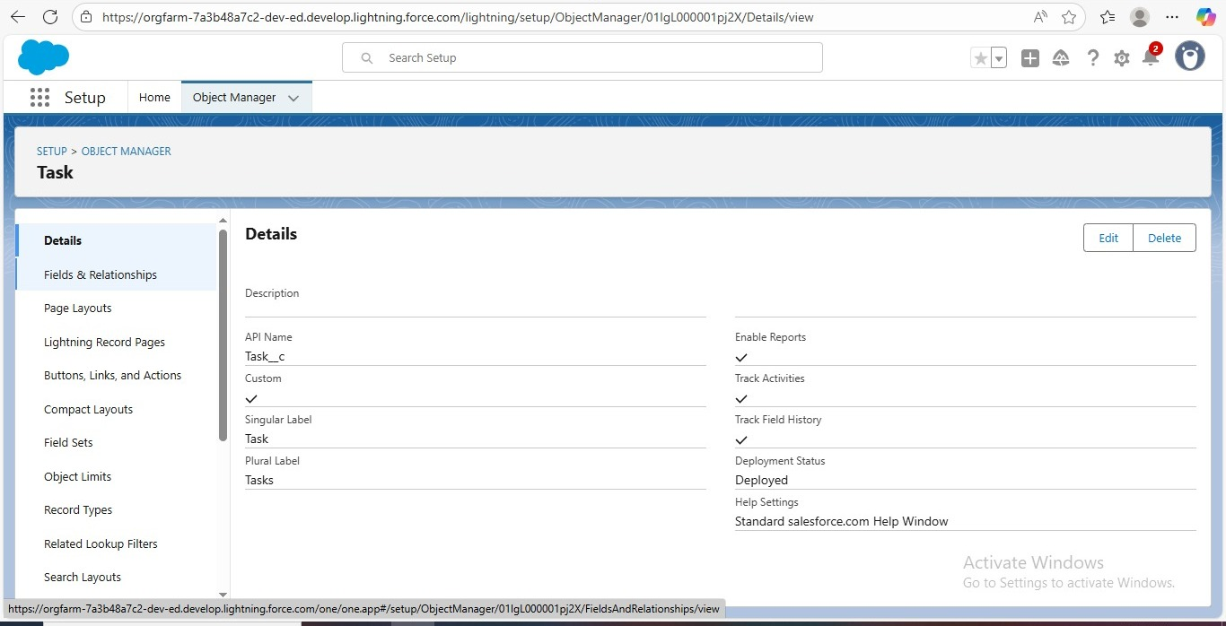

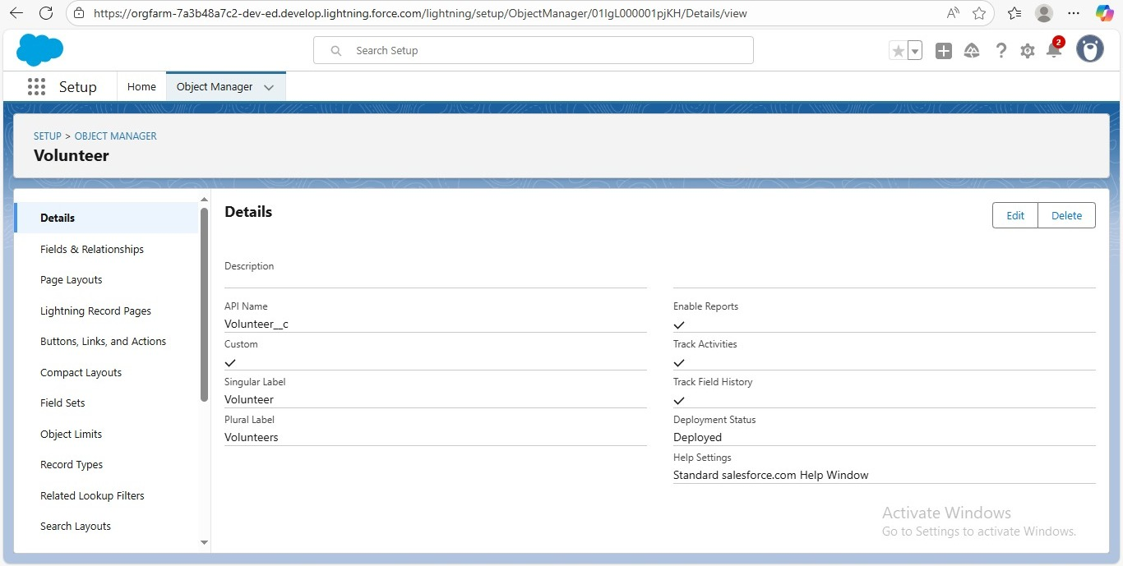

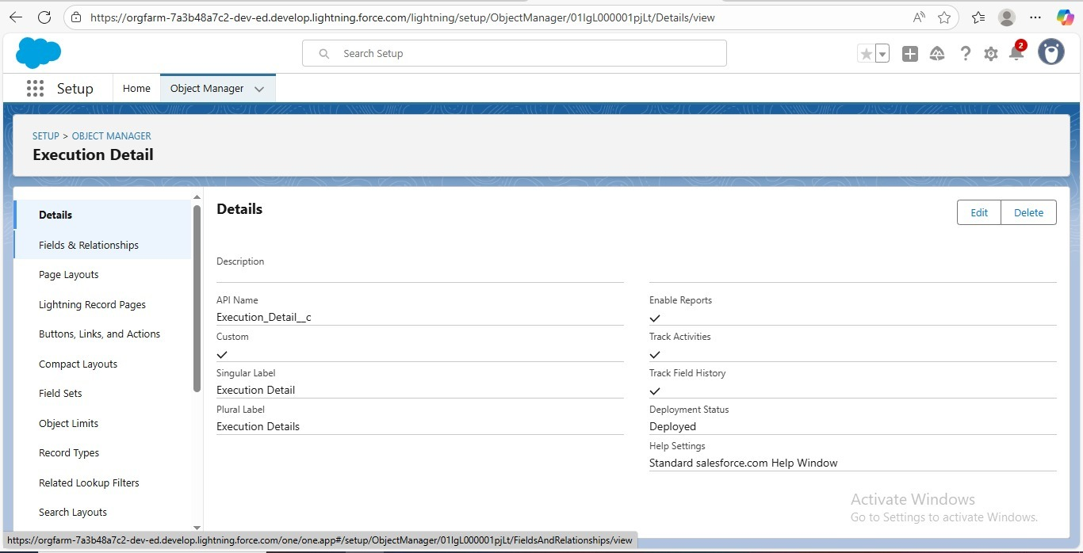

* **Creating Custom Tabs:**

Venue, Drop-Off Point, Task , Volunteer, Execution Details.

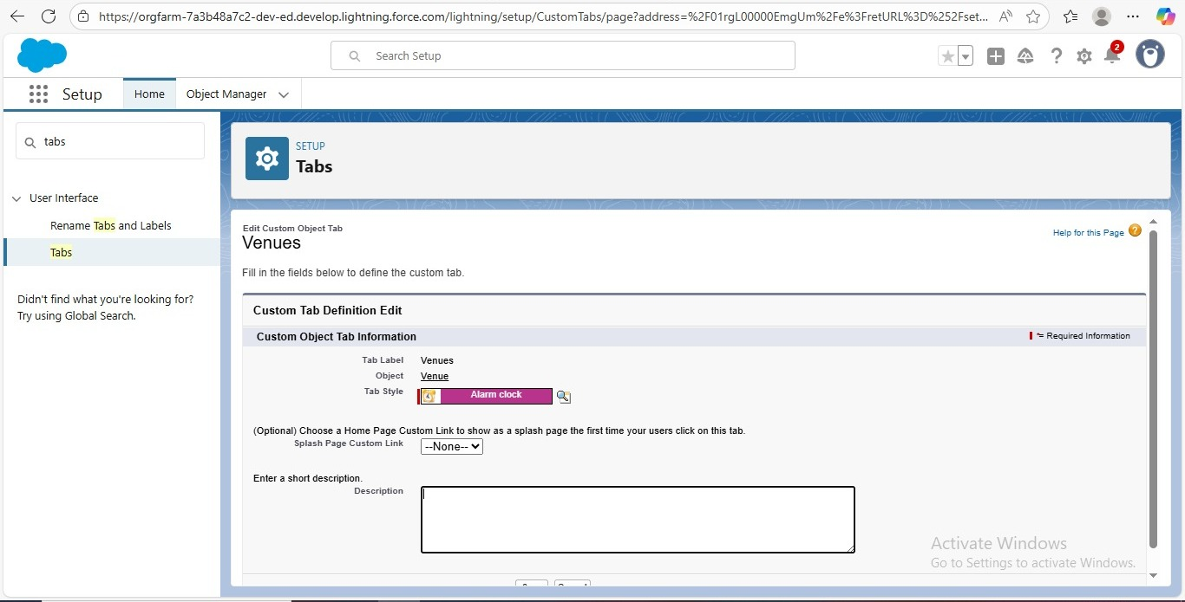

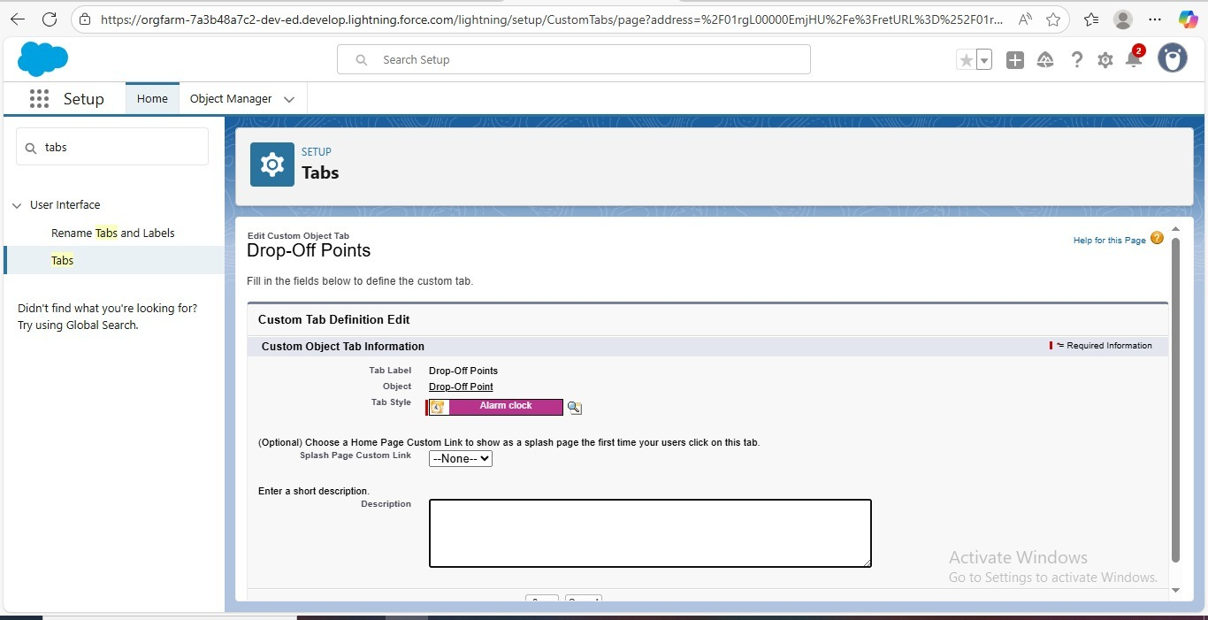

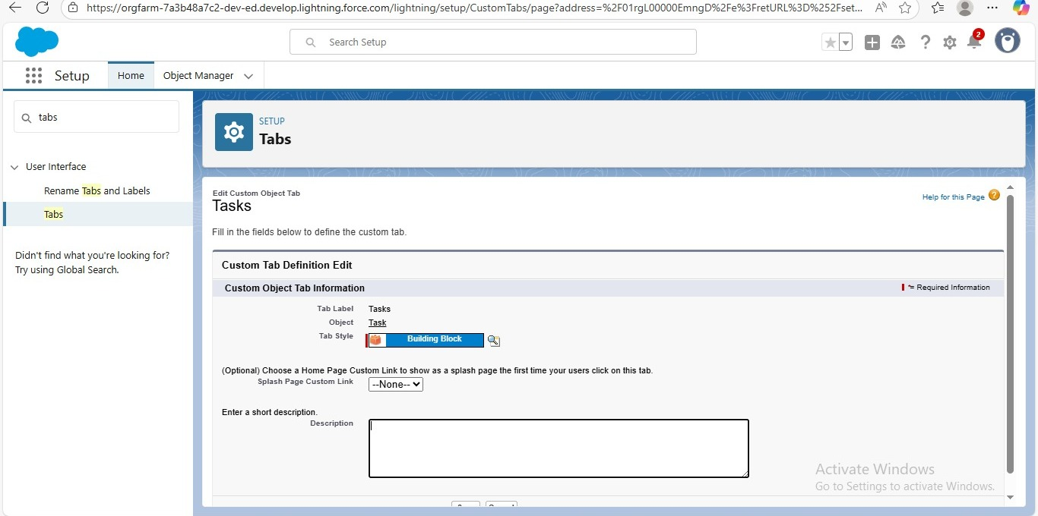

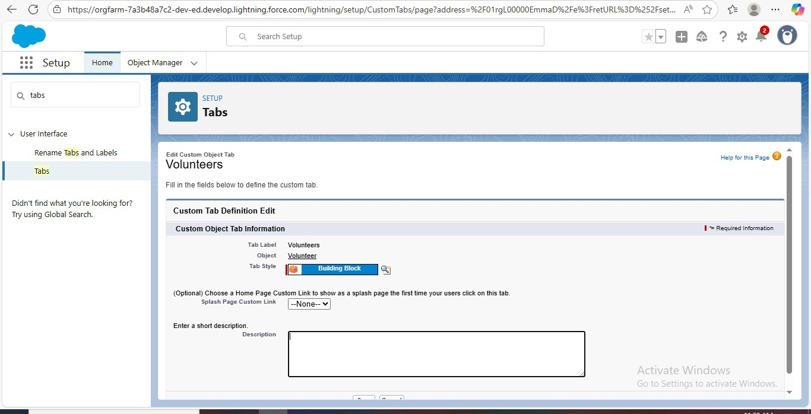

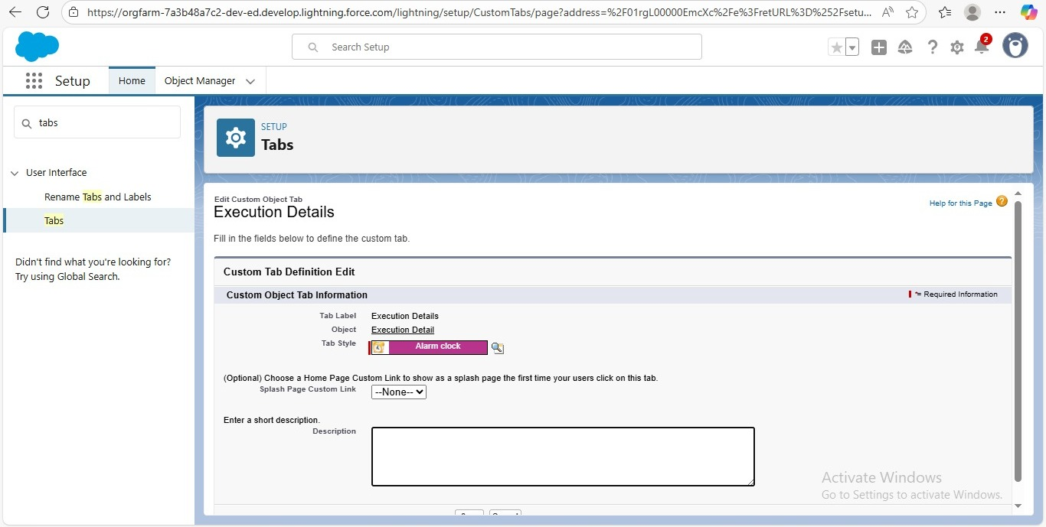

* **Lightning App Creation**

Creating an App to Use All Features in One Place.

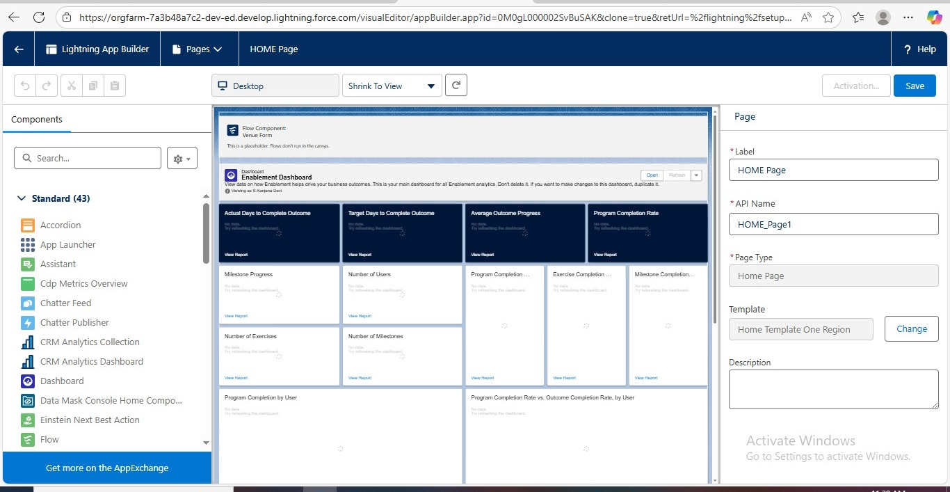

* **Fields**

1.Creation of Lookup Relationship field on Volunteer object:

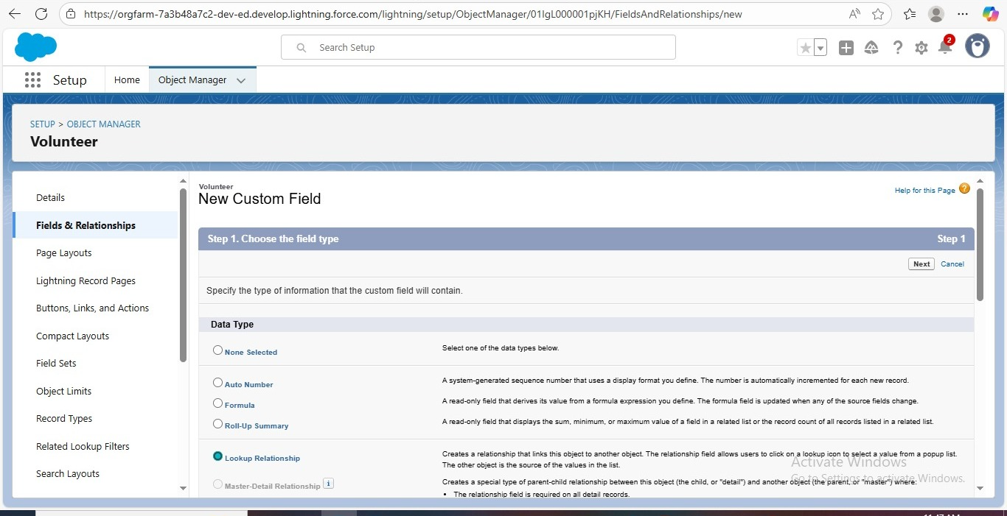

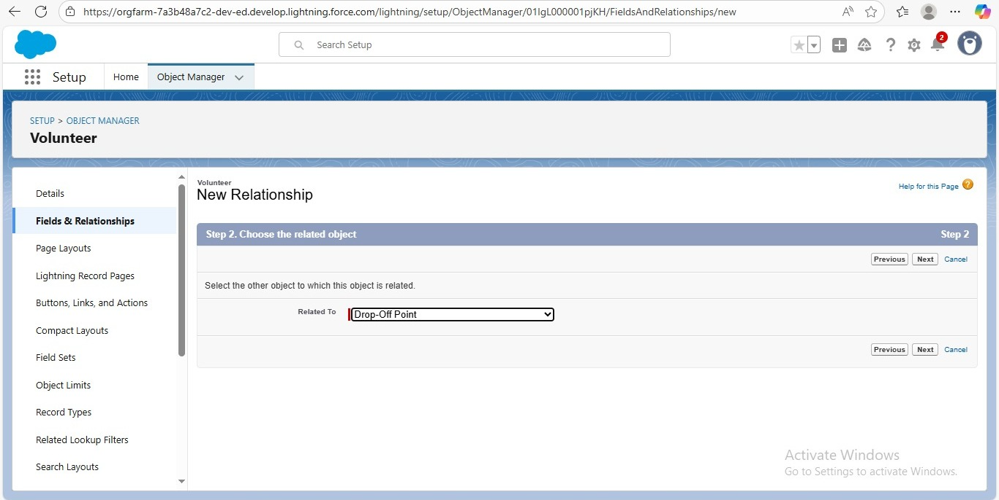

2.Creation of Master Detail Relationship field on Excution details Object:

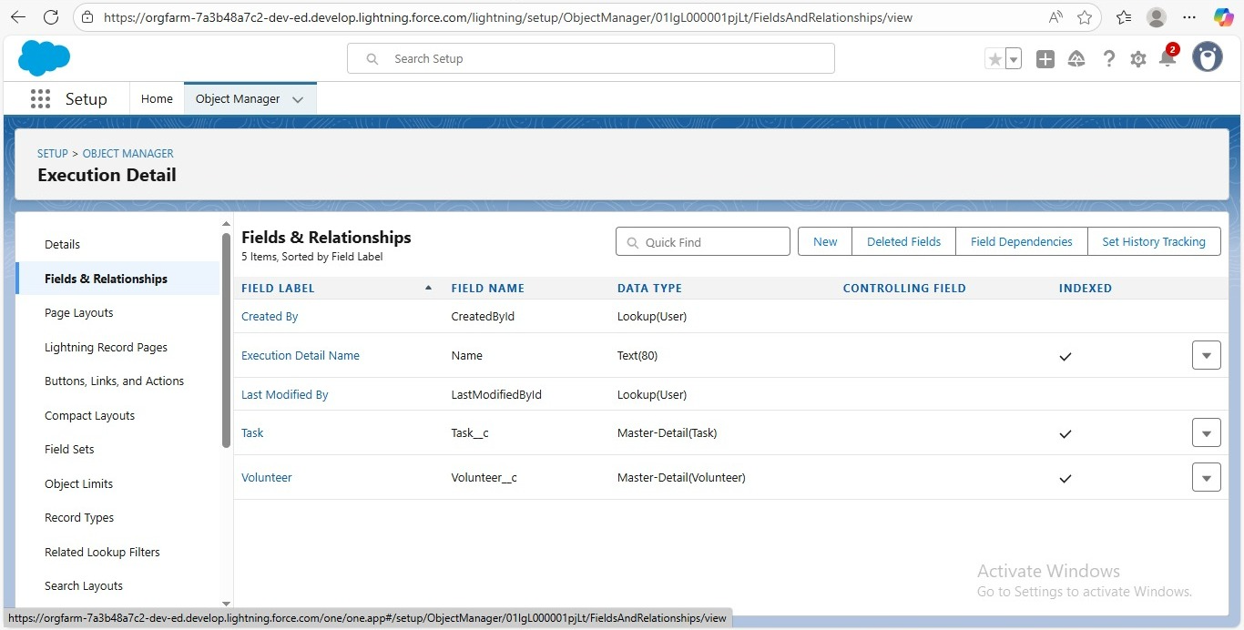

3.Creation of Lookup Relationship field on Drop-Off Point Object:

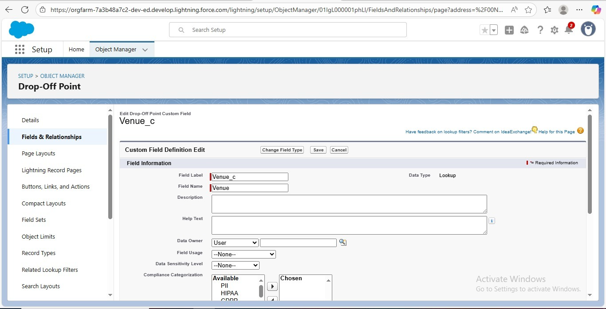

3.creation of Lookup Relationship field on Task object:

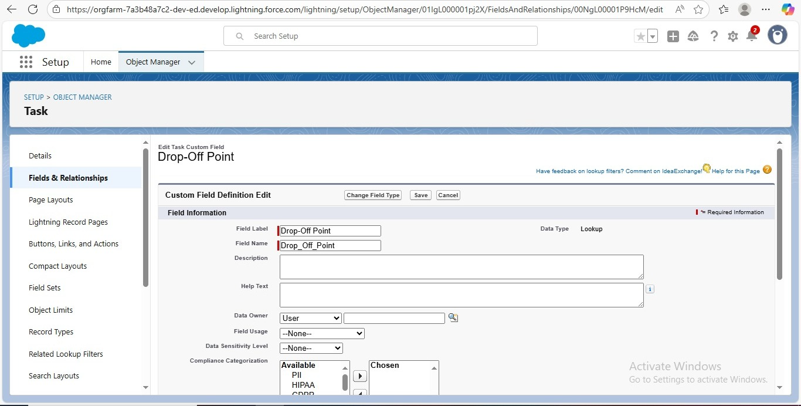

**Creation of fields for The Venue Object:**

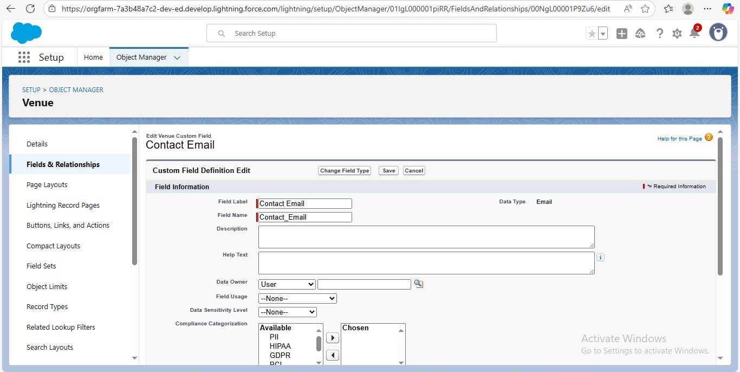

**Creation of fields for The Drop-Off Point Object:**

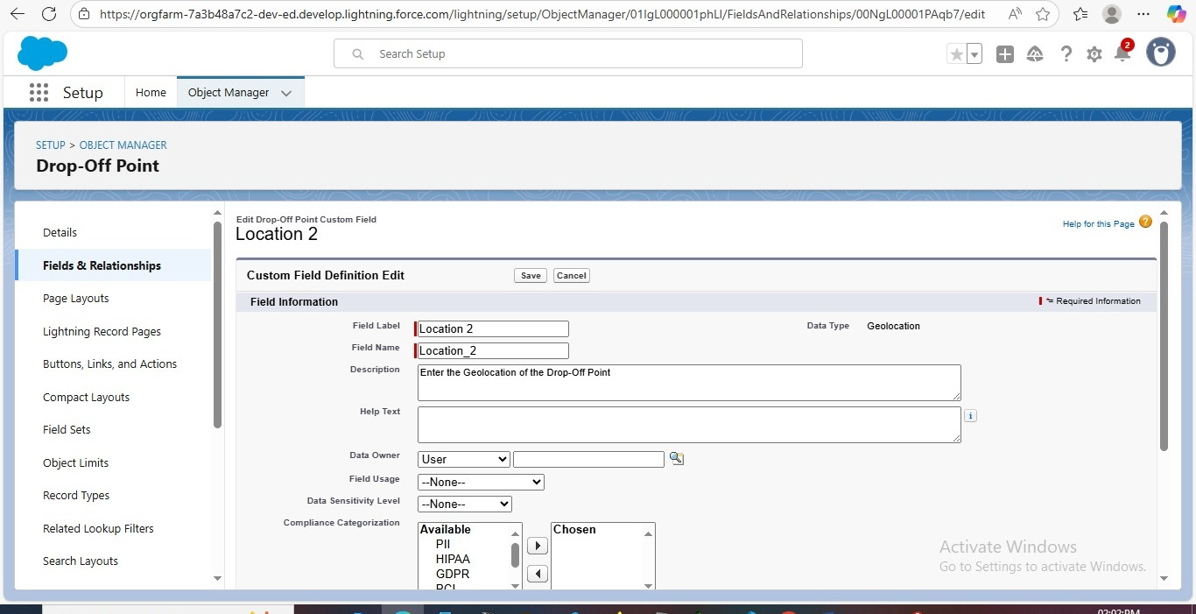

**Creation of fields for The Task Object:**

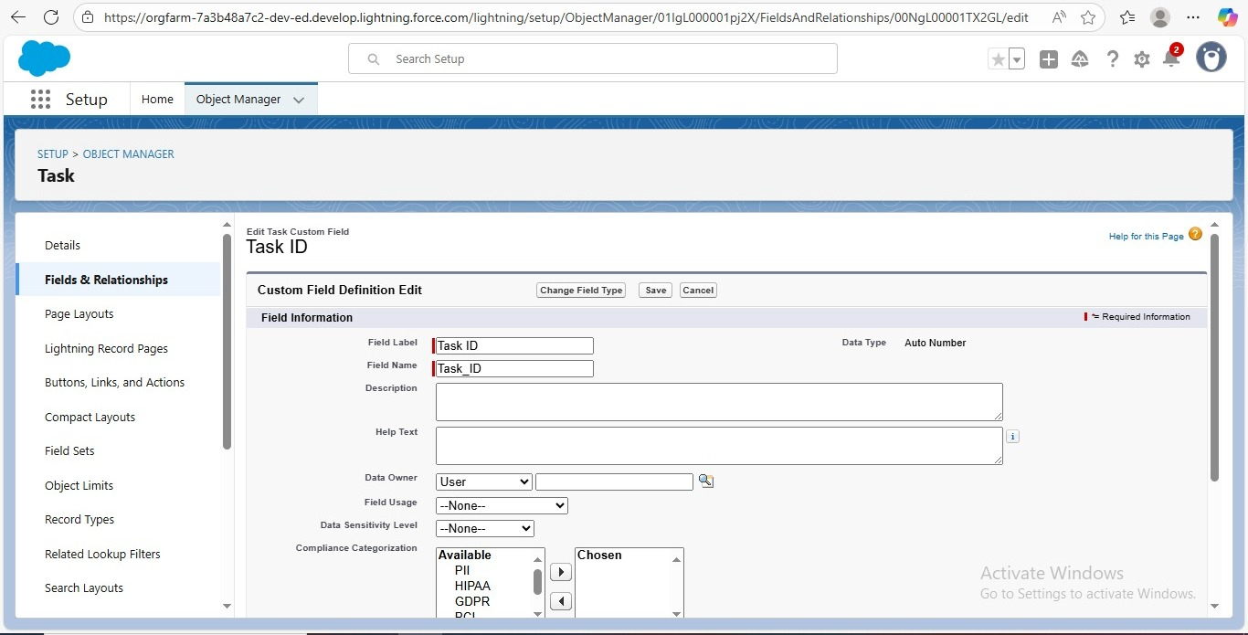

**Creation of fields for The Volunteer Object:**

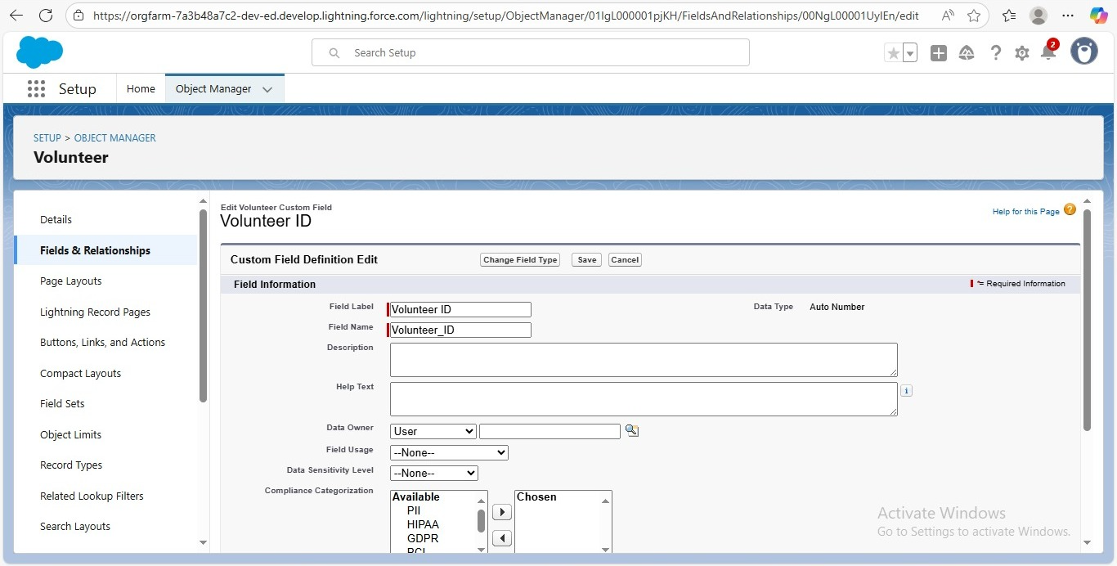

**Creation of fieds for The Execution Details Object:**

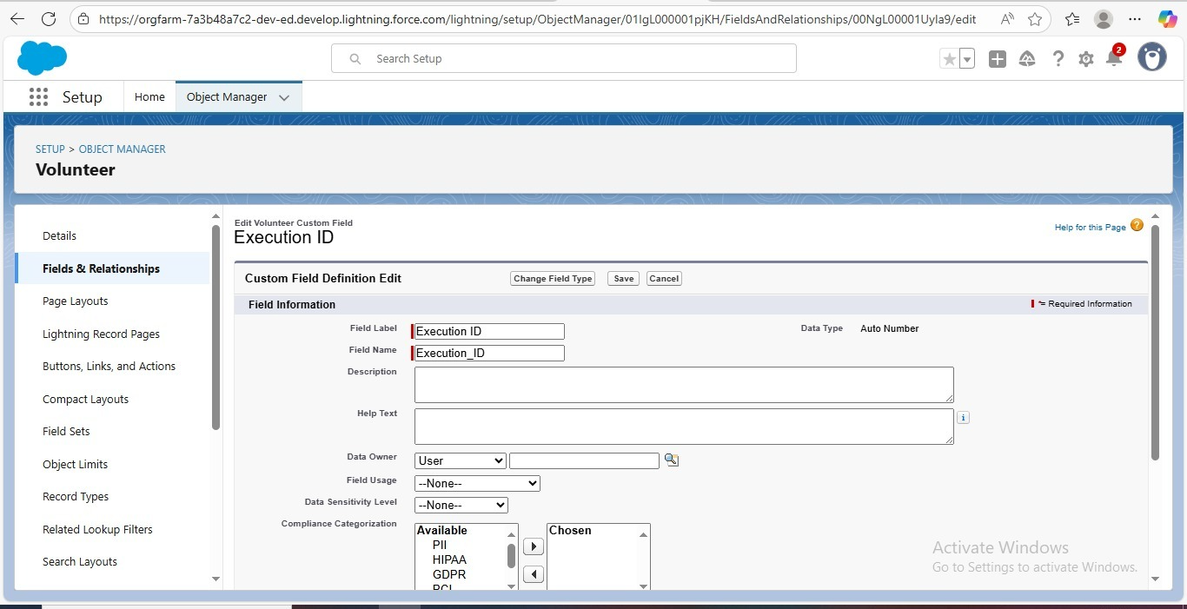

**FLOWS**

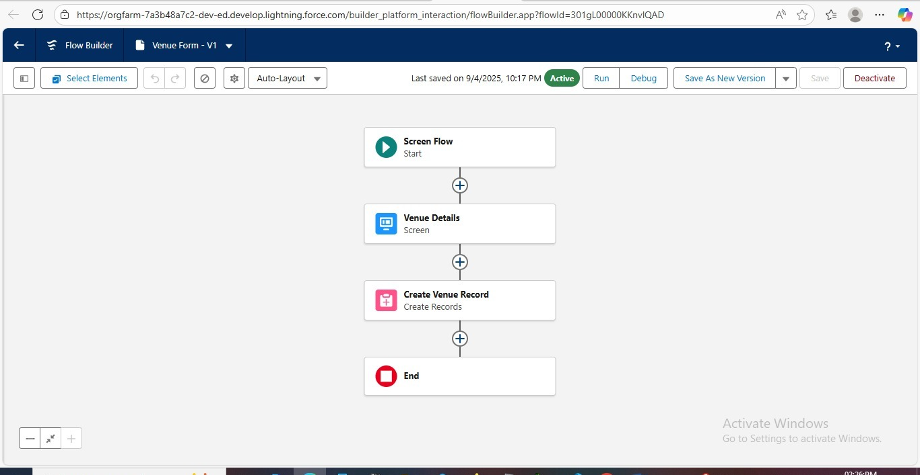

**TRIGGER**

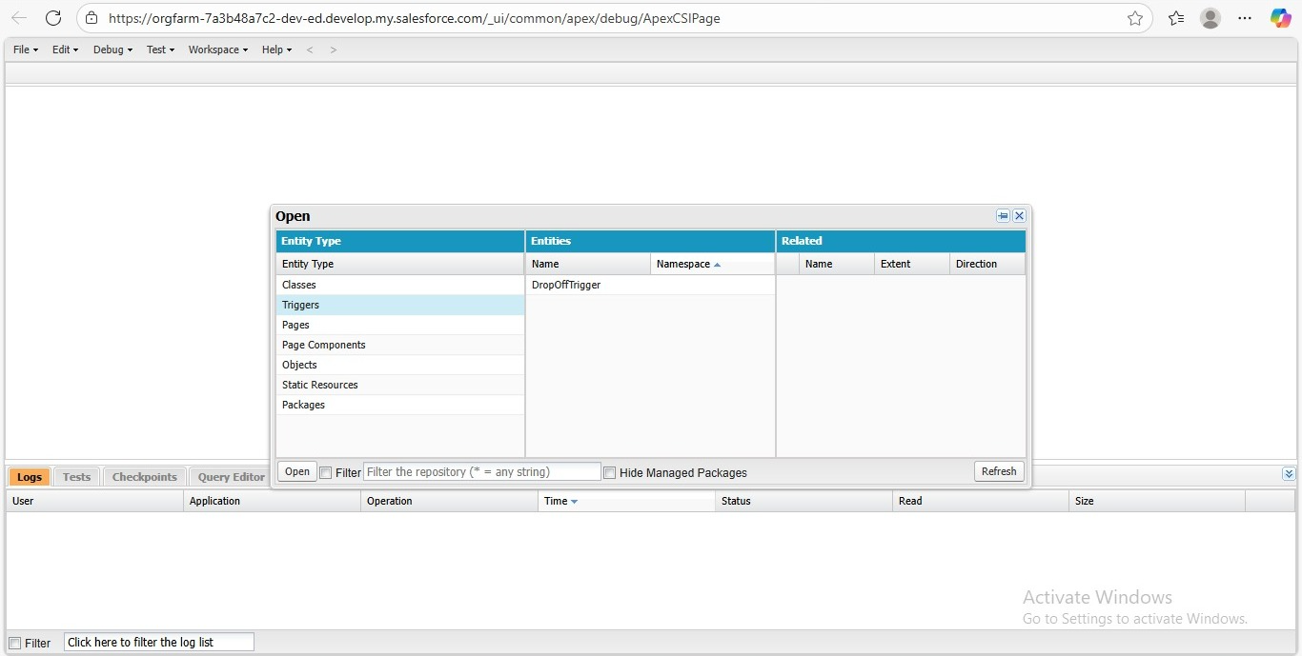

**Trigger code:**

**trigger DropOffTrigger on Drop_Off_Point__c (before insert) {**

**for(Drop_Off_point__c Drop : Trigger.new){**

**Drop.Distance__c = Drop.Distance__c;**

**}**

**}**

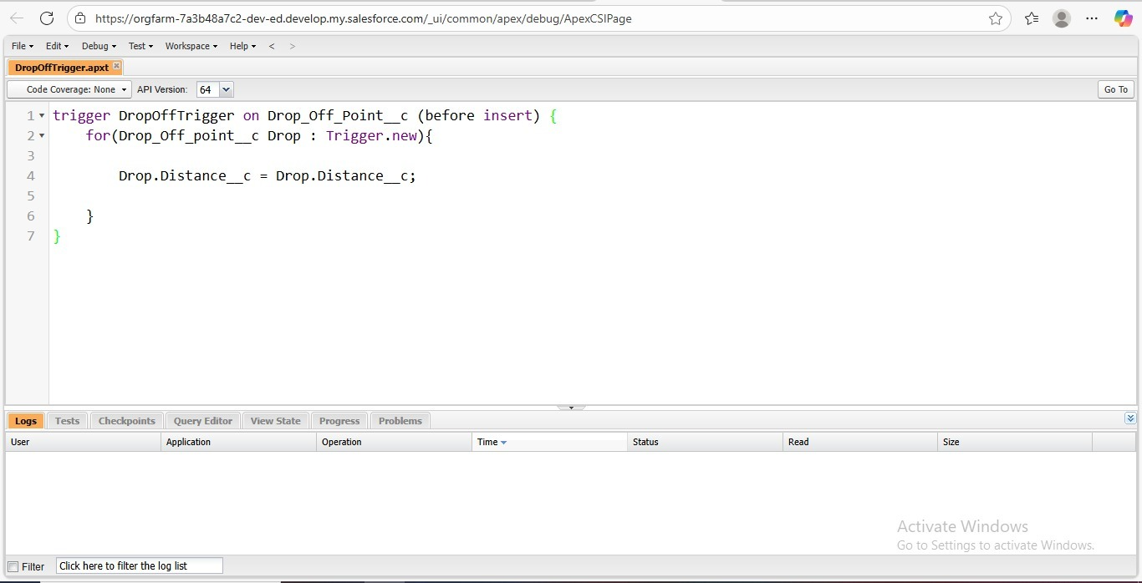

**PROFILE**

**Create Users**

**NGOs , Iksha Foundation , Street Cause.**

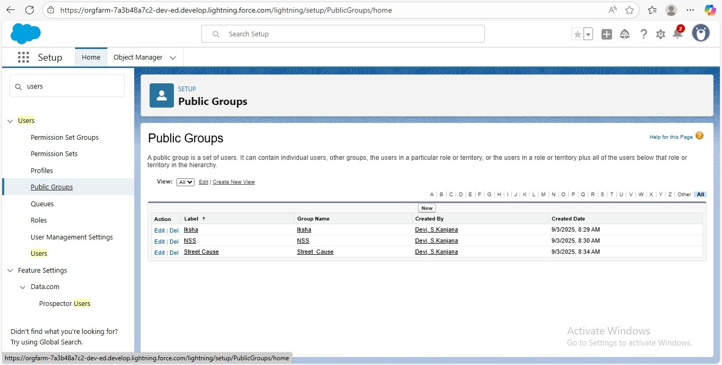

**REPORT TYPES**

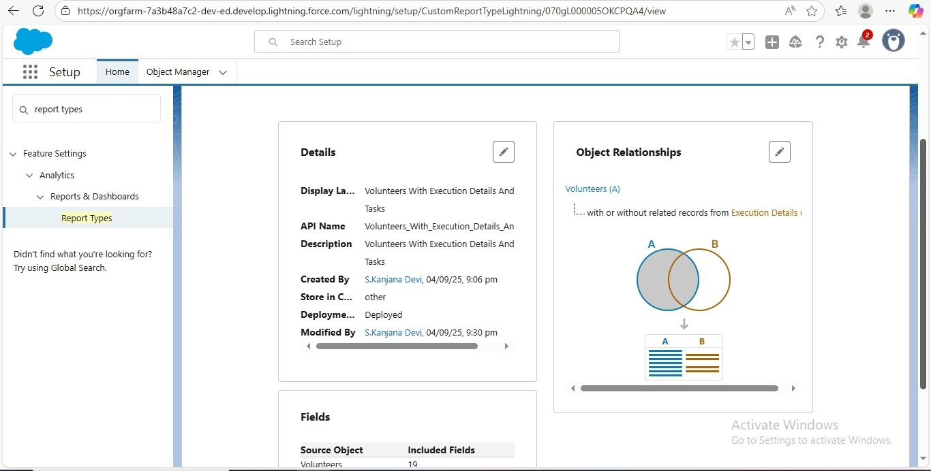

**Creation of Sharing Rules**

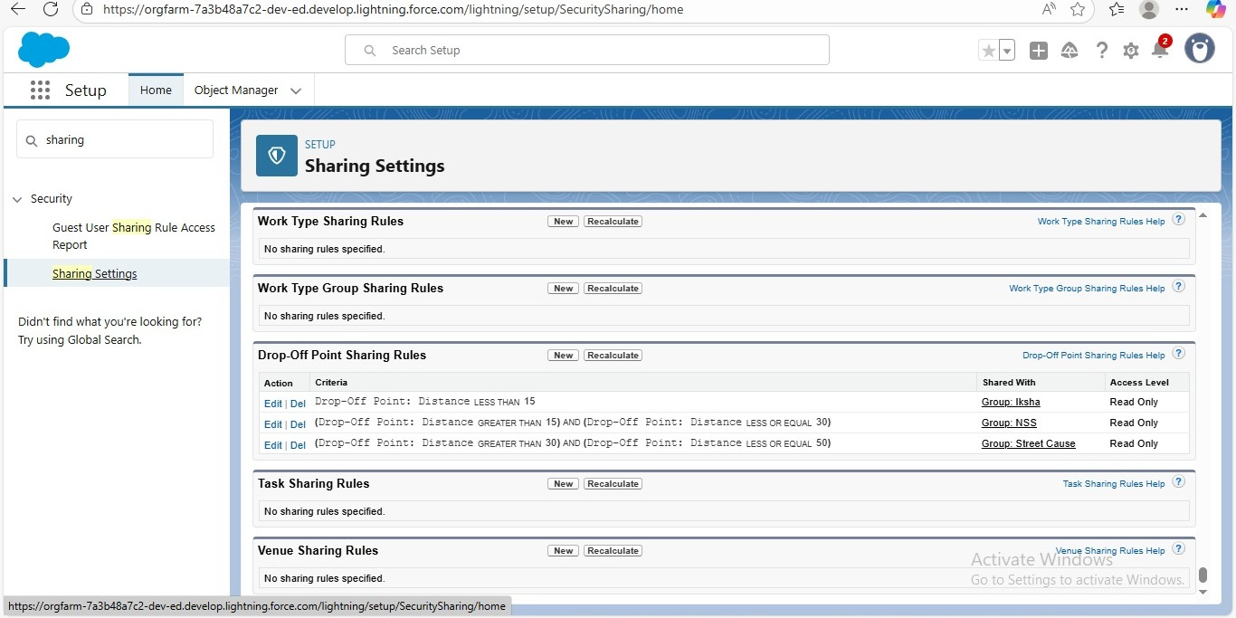

**HOME PAGES**

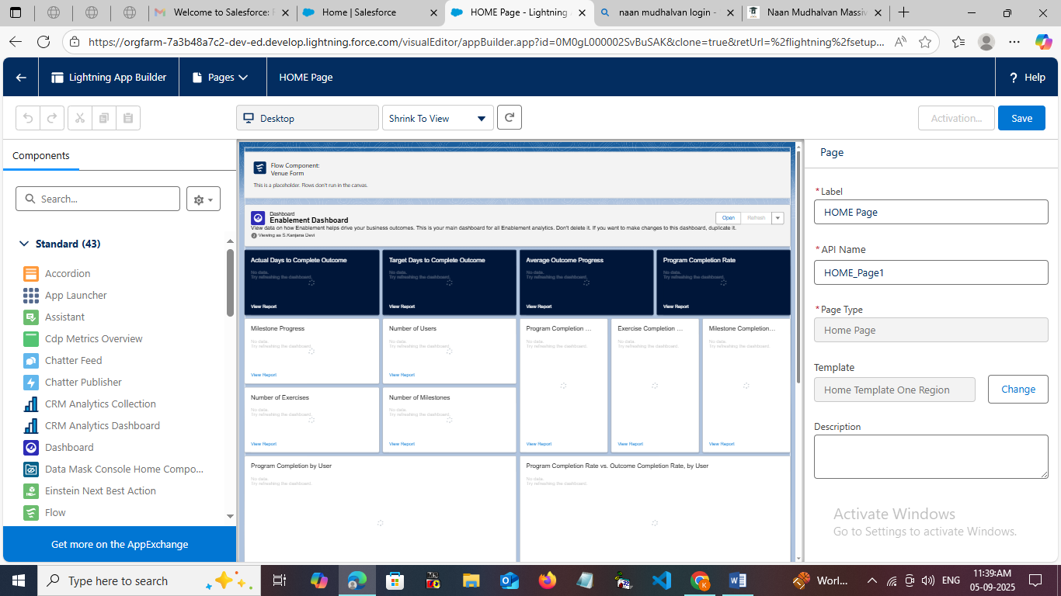

**PERFORMANCE TESTING:**

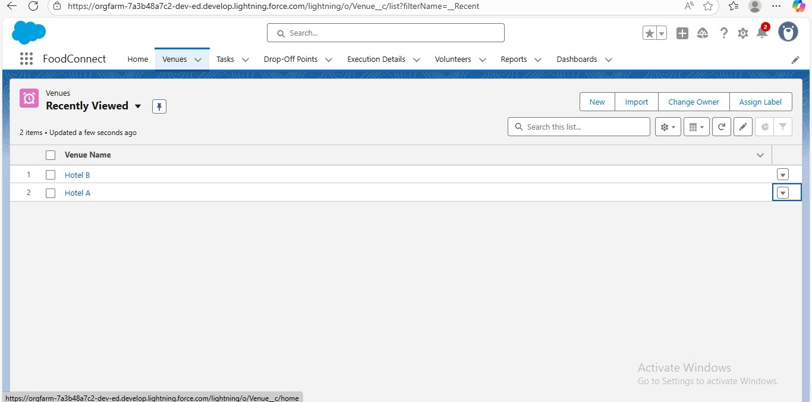

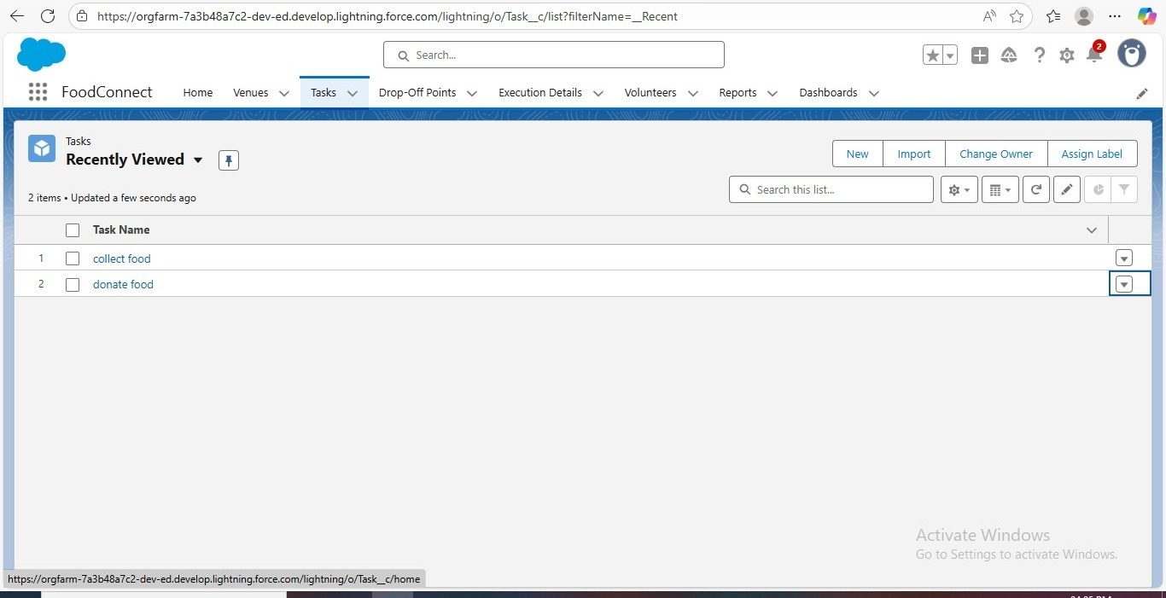

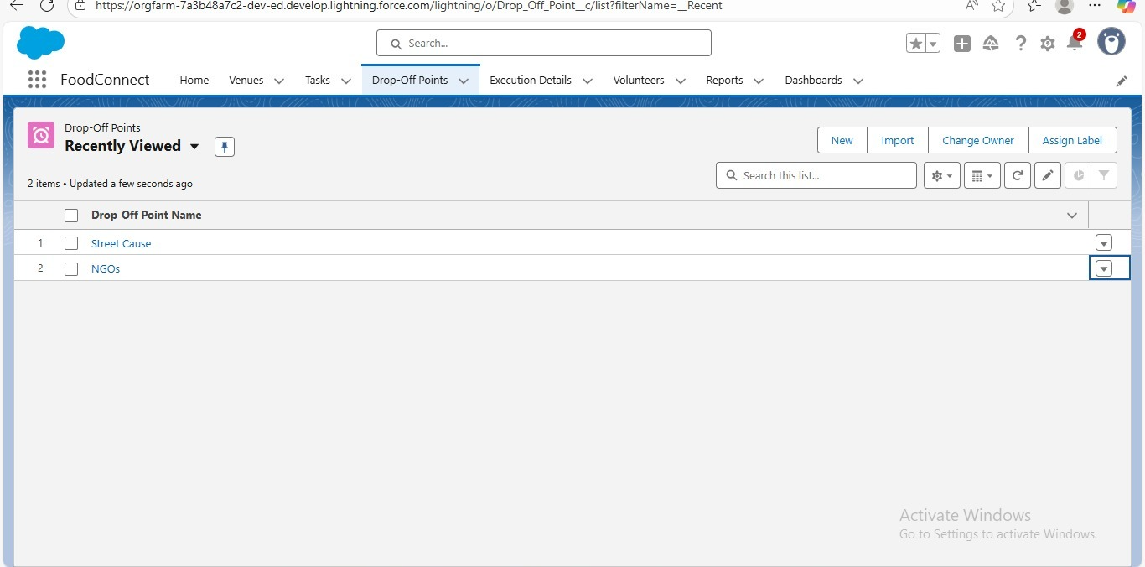

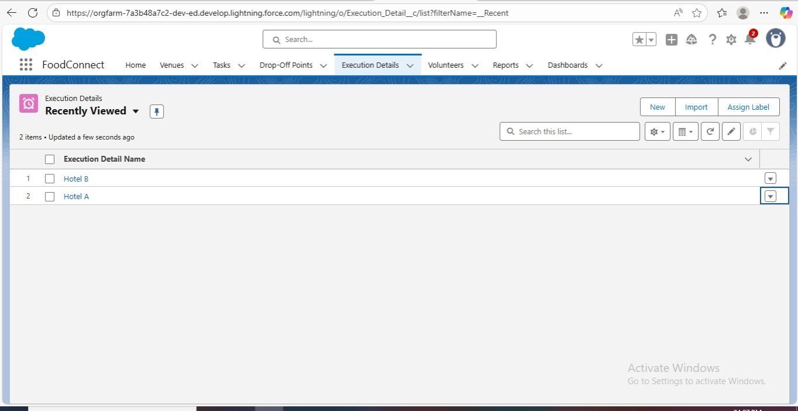

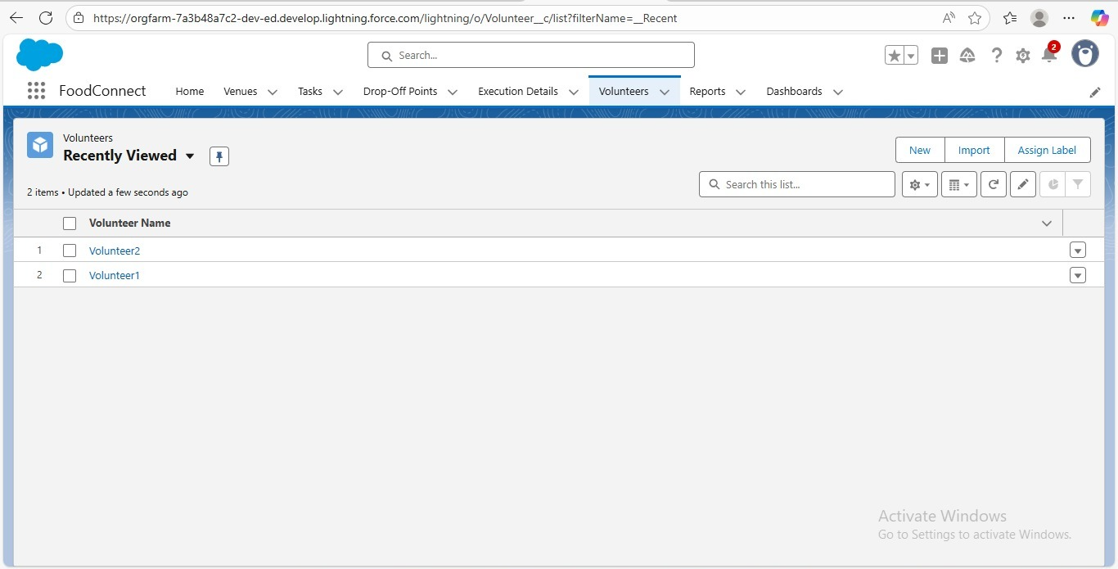

**RESULTS**

**Output Screenshots**

“How the food donation happens is displayed in detail on the screen, and the dashboard page we can understand it even more clearly.”

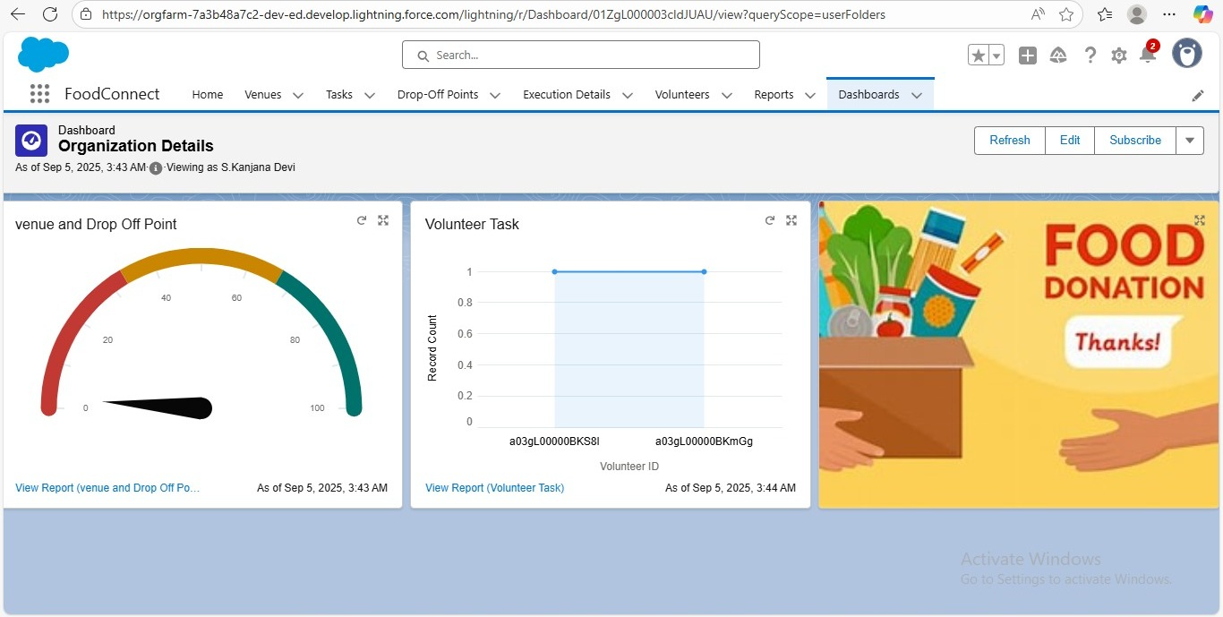

**ADVANTAGES:**

* **Food wastage is reduced.**
* **Poor people get timely food supply.**
* **Complete end-to-end tracking is possible.**

**CONCLUSION:**

By leveraging the Salesforce platform, the project successfully established a streamlined and transparent system for managing surplus food donations. Through efficient coordination with volunteers and timely delivery to beneficiaries, the project effectively addressed food insecurity while maximizing the utilization of available resources.